**MIGHT**

It means possibility, but, because it is on the past, brings the sense of less probability.

* When there is uncertainty about the time, whether it will happen in the present or future:

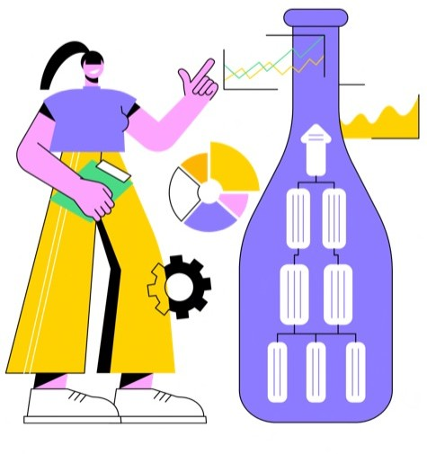*The algorithm* ***might*** *require fine-tuning for optimal performance.”*

*“*

*“*

**2- Put th**

*We* ***might*** *experience performance bottlenecks during peak usage.”*

# e sentences in the correct order, using ‘ca ‘could’, and ‘might’:

**n’,**

1. write/ algorithms/ I/ for/ data/ can/ processing./ efficient
2. please/ my code/ Could/ review/ provide/ and/ feedback?/ you
3. need/ the client/ to consult/ We/ for/ clarification./ might/ further/ with
4. use/ the user/ could/ a different/ to enhance/ He/ library/ interface.
5. integrate/ with/ APIs/ Can/ for added/ the module/ external/ functionality?/ you
6. might/ The development team/ the QA team/ for testing./ collaborate

with/

_____________

34

